### **Here’s How To Run an Online Skype Group:**

1. Open Skype to your group on the moderator's computer at least 2 minutes before your announced start time and if necessary, close all other apps and browser tabs except for "Daily Prayers." (This will free up your computer's electronic memory [RAM], so your computer isn't slowed down by "paging" – writing unneeded content to the hard drive and then reading it back into memory to keep your recording from becoming "choppy." It's because electronic memory that works at almost the speed of light is 1,000 times faster than the hard drive!)

2. In order to have a conversation, at least one other person must join the call, so in case nobody else is visiting remotely, every day at start time, you should use a different smartphone, tablet, PC, or Chromebook to start Skype in someone else's Skype account on this other device. Now go back to the moderator's device, either a PC or a Mac, 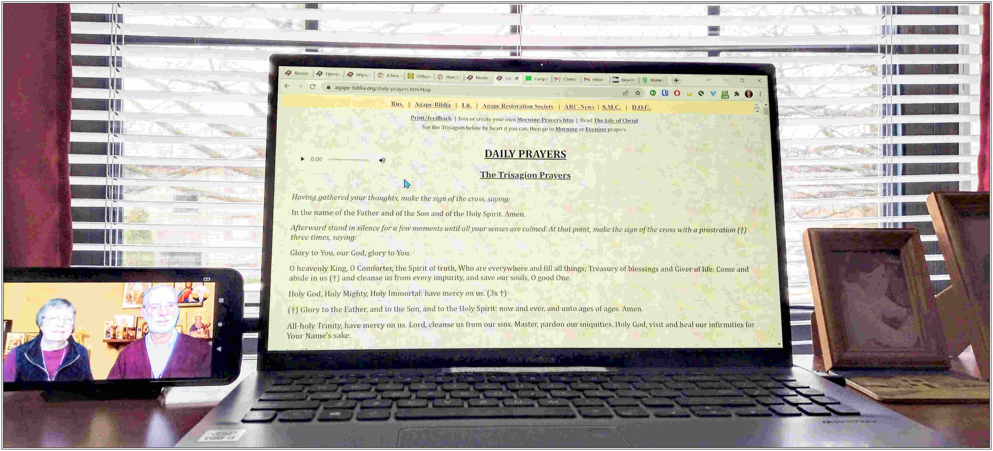open the web page for reading the "Daily Prayers" now, so you won't need to do it when it's time to share that screen in Skype (see step 7), like in this photo of our setup in our bedroom "recording studio": →

3. Open Skype to your group on the moderator's computer, click the camera icon in the upper-right corner of the screen, then the "Start Call" button on the bottom of the screen, to turn on the video, and immediately click the "Ring the group" button on the bottom of your screen, to notify everyone in your group that you're starting the video session. (If you pause before clicking the "Ring the group" button, someone may join the conversation and then you can't ring the group!) Set your video to "speaker view" so the video recording will just be of you and to reduce bandwidth use.

4. If that other device is in the same room, turn off its mic and camera in Skype **before** before you start recording to avoid "feedback squeal." To see how you'll look to your guests, adjust your camera on the moderator's device to be sure things look right on the other screen. This way, you'll be looking directly at the main screen's camera, instead of looking away from the camera.

5. On the moderator's device, select the 3 dots in the lower-right corner, select "Turn off incoming video,"then select "Mute others' mics" and remind guests to keep their mics turned off. This is to reduce bandwidth use. Then press the "Start recording" button. (If you want to, click the "Share screen" button so others can read the prayers with you.) Then press Alt-Tab to switch to the "Daily Prayers" web-page in your browser to read from the moderator's device, as long as your camera and mic in Skype continue to run.

6. Wait a second or two for your **moderated** recording of the video session to start, then welcome people to your group! If more guests join the group after you begin recording, remind them to turn off their microphones to avoid feedback while you're recording. Skype stores the recordings for 30 days, or you can download them from Skype and upload to a video server such as YouTube, Vimeo, etc.

7. To share what you'll be reading or another browser window such as "Lives of the Saints and Scriptures", click Skype's "Share screen" button and locate the desired browser tab or app, then switch to that window to see what you're sharing so that you can read it, scroll it, etc. To share a video with sound, be sure to press "Share computer sound" after you select the screen that you want to share. Then press Alt-Tab to see that screen. Remind your guests to hold their smartphones horizontally (in landscape mode) so they can see it better, because the moderator's computer screen is always in landscape mode. When you're finished sharing, press Alt-Tab to return to Skype and press "Stop sharing."

8. When you're done with the prayers and Scripture readings, on the moderator's device, press the "Recording" button to stop the recording. Tell guests to turn on their mics to visit with each other, set your video to "grid view" so you can see everyone, and when you're finished visiting, right-click the red hang-up button and select "End the call for all." But if others want to continue visiting, left-click the red hang-up button to end the call for yourself, and the video conversation will stay open until it's down to one person.

9. If you also started our group on another device and if it's in the same room, turn up the volume on that device; if needed, also go to "Settings" and turn up "Call volume."

It took us months of trial-and-error to refine this procedure, so "practice makes perfect." Let us know if it's unclear or you have any issues with it!