**~~~~~~~~~~~~~~~~~~~~~~~~~~~~~~**

# **On the Incarnation**

# **by St. Athanasius of Alexandria**

**~~~~~~~~~~~~~~~~~~~~~~~~~~~~~~~**

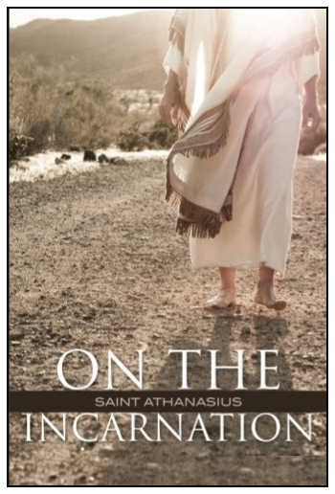

**On the Incarnation of the Word**

Athanasius of Alexandria was only 33 years old when he attended the First Ecumenical Council of Nicea in 325 as a deacon and the assistant to Bishop Alexander of Alexandria. Athanasius led the defense there against the heresy of Arianism which taught that Jesus was a godly man, perhaps a prophet, but just a created being (an idea later adopted by Islam). When Bishop Alexander died in 328, Athanasius was made bishop. Later he wrote a list of 27 books by the Apostles that was recognized as the official N.T. canon 24 years after his death in 373 by the Council of Carthage in 397. He was exiled from Egypt three times by various emperors, but was finally allowed to return to Alexandria and lead his flock there.

Please go to **[https://agape-biblia.org/literatura/#incarnation](https://agape-biblia.org/literatura/" \l "incarnation)** to get this classic [***On the Incarnation of the Word***](https://agape-biblia.org/literatura/On-the-Incarnation-5.5x8.5.htm): 92 pages formatted as a 5.5" x 8.5" booklet + [**cover**](https://agape-biblia.org/literatura/On-the-Incarnation-cover.pdf); or as a [**free e-book in *.epub format**](https://agape-biblia.org/literatura/On-the-Incarnation_St-Athanasius-of-Alexandria.epub), by St. Athanasius, Bishop of Alexandria (293-373). St. Athanasius was a great *"theologian, ecclesiastical statesman, and Egyptian national leader; he was the chief defender of Christian orthodoxy in the 4th-century battle against Arianism, the heresy that the Son of God was a creature of like, but not of the same, substance as God the Father"* (Britannica).

We also offer it as a short, 8-lesson online course "[**On the Incarnation of the Word**](https://agape-restoration-society.org/plugins/athanasius/)" at 10 a. m. “live” on Mondays and Fridays: click on “**JOIN”** here: [**https://agape-restoration-society.org/forum.htm**](https://agape-restoration-society.org/forum.htm) to join us!

(It will also be recorded, so go there to watch the lessons **anytime**.)

**Schedule:**

Mon., Nov. 28 – “Creation and the Fall”  
Fri., Dec. 2 – “The Divine Dilemma and its Solution in the Incarnation”  
Mon.. Dec. 5 – “The Divine Dilemma and its Solution – continued”  
Fri., Dec. 9 – “The Death of Christ”  
Mon. Dec. 12 – “The Resurrection”  
Fri., Dec. 16 – “Refutation of the Jews”  
Mon. Dec. 19 – “Refutation of the Gentiles”  
Fri., Dec. 23 – “Refutation of the Gentiles – continued” and “Conclusion”  
 **...then on Dec. 25,** **The Incarnation!  
  
(Enroll in the online course at** [**https://agape-restoration-society.org/plugins/athanasius/**](https://agape-restoration-society.org/plugins/athanasius/)**[)](https://agape-biblia.org/literatura/" \l "incarnation)**